CLUBS AND SOCIETIES WEB-BASED APPLICATION SYSTEM

Student No: 091937

Student No: 095070

An Information Systems Final Documentation submitted to the Faculty of Information Technology in partial fulfilment of the requirements for the award of a Degree in Bachelor of Science in Informatics and Computer Science.

Date of Submission: November 2017

# **Declaration**

We declare that this project has not been submitted to Strathmore University or any other University for the award of a Degree in Bachelor of Science in Informatics and Computer Science.

Students’ Signatures:

Sign: ________________________ Date: ________________________

Sign: ________________________ Date: ________________________

Supervisor’s Signature:

Sign: ________________________ Date: ________________________

# **Abstract**

Strathmore University is a leading non-profit private university operating in Kenya, aimed at serving the Kenyan society to the best of its ability. Strathmore holds a reputation for good quality education and personal formation (‘MIT Global Startup Labs - Partner’, n.d.). The students of Strathmore benefit from the clubs and societies programme, to take a break and join up in ventures that will benefit their careers.

The problem that the Strathmore clubs and societies programme faces is the lack of information that students receive about it, coupled with no distinct medium to propagate its messages and familiarise itself with the students. This creates no distinct drive in the students to join up, or actively participate.

A proper solution would be to create a web based student portal that easily connects the students to the clubs and societies, and through it garner up proper interest in a well-designed website that easily lures the students in and keeps them interested in it. The website should also help them to sign up and continually participate with ideas and experiences.

Thanks to the successful eLearning portal, there will be an ease in connecting and syncing student user data, promoting login and record keeping. It also promotes easy creation and maintenance of the website. The website will in turn make use of HTML, CSS, PHP, MYSQL, and the design implemented within the Strathmore based websites.

**Table of Contents**

Declaration ii

Abstract iii

List of Figures vi

Chapter 1: Introduction 1

1.1. Background 1

1.2. Problem Statement 2

1.3. Aim 2

1.4. Specific Objectives 2

1.5. Research Questions 2

1.6. Justification 2

1.7. Scope 3

Chapter 2: Literature 4

2.1. Introduction 4

2.2. Existing Systems and Applications 4

2.2.1. Strathmore University Clubs and Website 4

2.2.3. Jomo Kenyatta University of Agriculture and Technology (JKUAT) 6

2.3. Challenges faced by Customers using Existing Systems 7

2.4. Gaps in the Existing Systems 7

Chapter 3: Methodology 9

3.1. Introduction 9

3.1.1. Requirements Planning Phase 10

3.1.2. User Design Phase 10

3.1.3. Construction Phase 10

3.1.4. Cutover Phase 10

3.2. System Analysis 11

3.2.1. Functional Requirements 11

3.2.1.1. Enrolment of Members 11

3.2.1.2. Communication between Club Officials and Members 11

3.2.1.3. Enable Managing of Clubs by Officials 11

3.2.2. Non-Functional Requirements 12

3.2.2.1. Performance Requirement 12

3.2.2.2. Portability Requirement 12

3.2.2.3. Usability Requirement 13

3.2.2.4. Reliability Requirement 13

3.2.3. Narrative 13

3.3. System Design 14

3.3.2. Data Flow Diagram 16

3.3.3. Entity Relationship Diagram 17

3.4. System Development Tools and Techniques 17

3.4.2. HTML/CSS 18

3.4.3. MySQL Database 18

3.5. Deliverables 18

3.5.1. Student Module 18

References 19

Appendix 20

Appendix A: Time Schedule 20

# **List** **of Figures**

Figure 2.1: Strathmore University Clubs and Societies Website. 4

Figure 2.2: Strathmore University Website Application 5

Figure 2.3: University of Oxford Clubs and Societies. 5

Figure 2.4: Oxford Clubs and Societies Information. 6

Figure 2.5: JKUAT Clubs and Societies Website. 6

Figure 2.6: JKUAT Clubs and Societies Content. 7

Figure 3.1: James Martin Rapid Application Development 9

Figure 3.2: Performance Requirements 12

Figure 3.3: Club and Societies Web Based Portal System Use-Case Diagram 14

Figure 3.4: Club and Societies Web based Portal System Data-Flow Diagram 15

Figure 3.5: Club and Societies Web Based Portal System Entity Relationship Diagram 16

Figure A(1): Gantt Chart 20

# **Chapter 1: Introduction**

## **Background**

Strathmore College began in 1961 as the first multi-racial, multi-religious Advanced Level Sixth Form College offering Science and Arts subjects by a group of professionals. It was inspired by Saint **Josemaría Escrivá.** (Strathmore University, n.d.)

**Strathmore College later merged with Kianda College (**an undertaking of **Kianda Foundation) in January 1993, and moved to their current location along the Ole Sangale Road, Madaraka Estate.** (The Story of Strathmore, 2015)

**It has a total population of around 4393 students** (full-time and part-time) **all** studying Accountancy, Administration, Commerce, Finance, Management, Information Technology and other professional courses. (Kimani, n.d.)

In the year 2002, August, Strathmore University was awarded with a Letter of Interim Authority by the Commission of Higher Education, allowing it to operate as a University with a Faculty of Commerce and a Faculty of Information Technology. The first undergraduate students of these faculties completed their 4-year degree course in December 2004 and graduated in August 2005. (Strathmore University, n.d.)

The university inaugurated a clubs and societies programme when it was granted the charter. The programme allowed their students to be brisk and allow them an opportunity to relax and at the same time do something productive in their free time. The institution has a wide variety of clubs and societies that are available, namely **Strathmore University Information Technology Students Association** (SUITSA) club, Archery club, Japanese club among others. (Strathmore Clubs Management System, n.d.)

However, this system lacks in one pivotal area, and that is the lack of a proper website portal to enhance its ability to spread information quickly to the students, to keep them updated with new projects and activities and stay in virtual, instant and efficient contact with the student body.

## **Problem Statement**

The lack of a web based portal application system leads to students losing both interest and enthusiasm to join or continue with the club’s activities. Without a proper medium to deliver important messages, and without a way to advertise the available clubs and their programs, there is fallout, with students missing out on experiences whilst the institution’s resources waste away. The officials also lose out on the opportunity to connect and answer any queries.

## **Aim**

To develop a web based club management and social portal system enabling students to enrol for clubs, get updates, air their views and concerns and develop the clubs and societies programme within the school.

## **Specific Objectives**

1. To analyse the already existing clubs and societies website system available in Strathmore University.
2. To investigate the challenges faced in handling the clubs and societies in Strathmore University.
3. To design and develop a clubs and societies web based portal system.
4. Test and deploy a clubs and societies web based portal system.

## **Research Questions**

1. What are some examples of existing clubs and societies website portal systems available in Strathmore?
2. What are the challenges faced in handling the clubs and societies in Strathmore University?
3. How will the clubs and societies website portal system be developed?
4. What test cases will be developed to examine the system’s performance?

## **Justification**

This system benefits from an already placed and successful web based portal system in the guise of the eLearning portal. Linking the two through the already established user accounts and passwords and the proper and efficient website design, allows the system to easily incorporate new tasks and actions such as heavy interaction between users and clubs.

## **Scope**

The resources in use include My Structured Query Language (MySQL) database holding all the needed information and details of concurrent users. Hypertext Mark-up Language (HTML), Cascading Style Sheets (CSS), JavaScript, and Hypertext Preprocessor (PHP) are implemented into the website design and versatility.

Challenges faced include incorporating and connecting the web-app system to the eLearning platform, together with managing a MySQL database handling all the users accessing the platform. Also, creating a social page for each of the already registered clubs and societies, while trying to give each a distinct taste and feel unique to its own culture.

# **Chapter 2: Literature** **Review**



## **Introduction**

This chapter reviews the existing literature on the current web based clubs and societies management situation in Kenyan universities, existing clubs and societies management systems, the trends used, adoption of the student portal, as well as in other countries. It begins by exploring the existing challenges in the current clubs and societies website in used and conclusively depicts the various trends used in the latest students’ portals.

## **Gaps in Existing Systems and Applications**

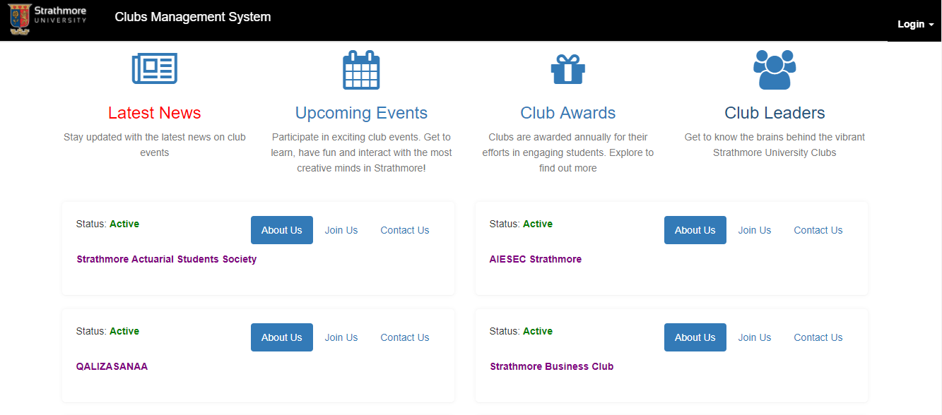Upon reviewing existing website systems, we noted that some hold few functional elements, as the case with the Strathmore University club management system.

Figure 2. : Strathmore University Website Application Source: https://apps.strathmore.edu/clubs/#

As shown above in Figure 2.1, the About Us button holds no use. Even the links to ‘upcoming events’, ‘latest news’, ‘club awards’ and ‘club leaders’ has no proper response, or expected change in the webpage. We solved this by building the website with as much interactivity and aesthetically appealing design to captivate the users. A feed is also present to show all the recent club posts and upcoming events appearing immediately upon logging in.

The existing website systems also lack enough club detail, or a brief description of the available clubs, or provide a link to such. Our solution is to dedicate an entire web page to the list of clubs, upon which an aspiring student can read about, choose a favourite and join.

In our system, we assigned the necessary responsibilities to the administrator like recording club activities, meetings or events which is all available on his or her module page.

## **Challenges faced by Customers using Existing Systems**

Customers are forced to rely on posters and the word of mouth as their source of information about club activities. Rarely are emails sent to the members and on the few occasions that the officials have arranged to create a WhatsApp group for all members, they use the social media platform to deliver news and messages.

The design behind the website also lacks any initiative, innovation and a radiating energy to attract others and set it apart. Club management undertaken by the officials is heavily manual and tiresome, with poor record keeping systems and procedures.

# **Chapter 3: Development Methodology**

## **Introduction**

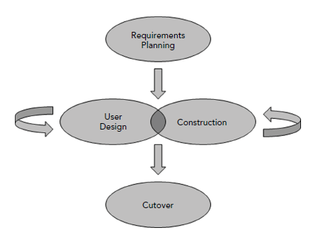In the making of the Club and Societies Web Based Portal, we use the James Martin Rapid Application Development model, which encourages continuous input of, and from, users while making of the system.

## **Development Model**

The techniques available in the James Martin Rapid Application Development Model pushed us as developers to make high quality code as fast as possible(Stephens, 2015,p. 304). The

James Martin Rapid Application Development Model has the User design phase and Construction phase which are iterative and helps in adjusting and making changes to the system with ease as shown in the diagram above(Stephens, 2015,p. 308).

Figure3.1: James Martin Rapid Application Development Source: Beginning Software Engineering by Rod Stephens.

A Club and Societies Web based portal system requires that students, or club members, constantly interact with it. The reasons for why the James Martin Rapid Application model is best for this project are as follows:

The model emphasizes on user interaction all through the design and construction phase, the James Martin Rapid Application Development model helps us give the users a system they can easily understand and use, while also have all their needs they require.

The model uses iterations in the user design and construction phase, allowing developers to improve on the systems features with each iteration and refine on the system while removing errors that may be found during construction.

## **Stages in The Development Model**

## **Requirements Planning Stage**

Here, the users, developers, and all stakeholders agree on the what the project is supposed to achieve together with its requirements. The requirements should be clear and agreed upon by all stakeholders to avoid restricting development later on(Stephens, 2015). The activities conducted in this phase are research of existing club and societies web portals, the new system improvements, and proper planning on how to usage. By understanding the user and system requirements, this can be achieved (Sommerville, 2016).

## **User Design Stage**

This is where analysts speak to users and get a vision of what they need from the system. Users and team developers convert the requirements into a workable design(Stephens, 2015,p.308). Activities are coming up with Use-Case diagrams, Data-Flow diagrams, and Entity Relation Diagrams. These help the developers know what the users need during implementation. There is continuous interaction with users to refine and meet their need(Stephens, 2015,p.308).

## **Construction Stage**

Here, the developers begin coding, application development and testing the system. Users are still constantly consulted to provide suggestions for improvement and corrections (Stephens, 2015). Activities are done through iterations to add features that users may want and moving back to design phase is possible.

## **Cutover Stage**

It focuses on the deployment aspect, which involves, testing, changing over to the new system, and user training(Stephens, 2015). The system needs maintenance after a successful deployment. Maintenance will mean constant improvement of outdated modules, securing, and fixing of any problems that come up during use. This stage is undertaken till the system is phased out.

## **Deliverables**

## **Student Module**

A student uses their student number and their eLearning password to access the system. The student can join a club of their choice. From there the student can get informed on the club activities, ask questions about the club, and comment on club post.

## **Club Official Module**

Each club has club officials. They are able to edit their club’s profile and view the members details. The officials are able to contact individual members through email details given during registration. The officials can post upcoming activities on the club page to inform members of it.

## **Administrator Module**

The Clubs’ Administrator is the head of clubs and societies for the school. They are able to get information of meetings held by the different clubs i.e. the meeting’s purpose, the people in attendance and minutes will be sent to them. They also have all the abilities of the club officials for all clubs, that is, view the club members, post activities, and edit club information.

## **System Tools and Techniques**

System tools and techniques are methods used in the implementing of the various stages of the system’s development. This includes modelling, prototyping, and computer aides systems engineering tools. They are used for planning in a team environment and for the system implementation (Galeon, n.d.).

## **PHP**

This is a server-side scripting language used to connect a HTML page to a database. The Club Management System has a database storing the members information for each club. The PHP enables fetching data and executing queries to and from the database.

## **HTML/CSS**

Hypertext Mark-up Language is a programming language that is used to create web pages and web application. Cascading Style Sheet is a language that is used in the formatting and presentation of web pages. The Club Management System is a web based application. HTML is used to make the web pages and CSS is used to format each page accordingly.

## **MySQL Database**

The Structured Query Language(MySQL) database is a Relational Database Management system that uses querying to insert, update, delete or select data. A MySQL database is used to manage and store the system’s data.

**Chapter 4: System Analysis and Design**

## **System Requirements Analysis**

It is the study of the process to help understand key characteristics and how such processes are performed in practice by the stakeholders. In short, you are trying to understand what is going on in a process. You need to carry out analysis to know what to measure (Sommerville, Software Engineering, 2016). To understand the activities involved and the relationship between the activities, to relate the processes that you are analysing to comparable processes elsewhere, and to understand the activities between the process activities and the measurements that have been made are activities to be done during the analysis phase(Sommerville, 2016).

## **Functional Requirements**

The Requirements in a system are the descriptions of what the system can do, the services that it provides and the constraints in its operations(Sommerville, 2016, p. 85). Functional requirements are statements of services the system should provide, how the system should react to particular input, and how the system should behave in particular situations(Sommerville, 2016). Functional requirements for the Clubs and Societies Web based portal include:

## **Enrolment of Members**

Users can join clubs they want through the system. The user enter their credentials, email and contact details and join the club of their choosing. This should aid in linking clubs to students that wish to join them.

## **Communication between Club Officials and Members**

Officials have a list of their members and a means to reach them. That is, officials can post events on the page. They also have their emails which helps for easy communication from the officials to the members. Members can ask, comment or even inform other members and officials on the page. This makes the link between clubs and students stronger.

## **Enable Club Management by Officials**

Officials of respective clubs can add or remove members from their clubs, call for meetings, control the advertising of their club and view the number of members they have. This helps them plan club events and activities easier since they have a picture of the clubs’ size and what to expect.

## **Non-Functional Requirements**

Non-Functional Requirements are constraints on the services or functions offered by the system. They apply to the system as whole rather than individual system features(Sommerville, 2016). They are statements about the quality of the application’s behaviour or constraints on how it produces a desired result (Stephens, 2015). Non - Functional requirements for the Clubs and Societies Web based portal include:

## **Performance Requirement**

This deals with how fast the system will execute and how much space it requires(Sommerville, 2016). The Club and Societies Portal works efficiently on a machine with the at least the system features shown in the figure below.

Figure3.2: Performance Requirements

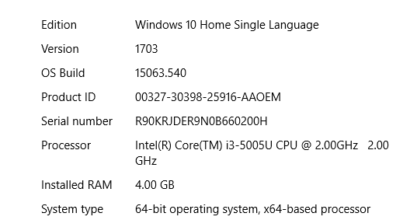

The system is a web based system and thus requires connection to the Internet. The speeds at which one is connected, be it Wi-Fi or data connection, also plays apart at how efficiently one acquires the information from the system.

## **Portability Requirement**

Portability requirements are constraints on the number of target systems and how many it reaches (Sommerville, 2016). The Clubs and Societies system is web based, thus it is accessible on the Internet through a mobile phone or laptop. Therefore, the system is easily portable from one device to another through the Internet.

## **Usability Requirement**

What the system looks like, describing user oriented features such as general appearance and ease of use (Stephens, 2015, p. 64). The Club and Societies system is developed with user’s input in every step, this and the already existing similarity to the school’s eLearning portal helps students find it easy to use and quickly to take to it.

## **Reliability Requirement**

How reliable the system is, it indicates things like when the system is available and how accurate the system is(Stephens, 2015, p. 64). The information from the system is available to all those with correct credentials, that is, school ID number and eLearning password and have an Internet access. The system is online always. The information gotten from the system is accurate since only the club officials and the clubs’ administrator can edit a club’s details.

## **System Narrative**

The Club Management system is a web based application that enables students of a University to register and join to a given club. It is available as a plugin to the school’s eLearning platform.

Members are able to get information of given clubs, for example, what they do, what you can gain from being in the club. Members of different clubs are able to ask questions on areas they may need help through the system. They can also post activities they think might be useful to fellow members. It is therefore a very interactive forum.

Club Officials can advertise and communicate to their members on matters pertaining their club. For example, if the Japanese club will be visiting a Japanese museum, the officials can post this information on their page, explain what you need to do to go, when it is. Club officials can set the club details and answer any issues from the members. They can also have the contact details of their members making it easier to contact a member individually.

The Clubs’ administrator will have a bird’s-eye view of all clubs. They can get information from their officials such as meeting details. The administrator has all capabilities that each official has, that is, edit club information, view members details, post club activity.

## **Design Diagrams**

Description of the software structure to be implemented, the data models, the system structures, and interfaces between the system components(Sommerville, 2016, p. 38). It involves identifying and describing the fundamental system abstractions and their relationships(Sommerville, 2016, p. 31). The ways in which one can show the system designs are through diagrams such as the ones shown below.

## **Use Case Diagram**

The Use Case Diagram is used to describe the interactions between the system and external factors (Sommerville,2016, p.142). Figure 3.3 shows, the system has three actors, namely, Clubs’ Administrator, Club Official, and the Club member. Each interact with the system in a different way as shown using the use cases.

Figure3.3: Club and Societies Web Based Portal System Use-Case Diagram

Club Management System

Club Management System

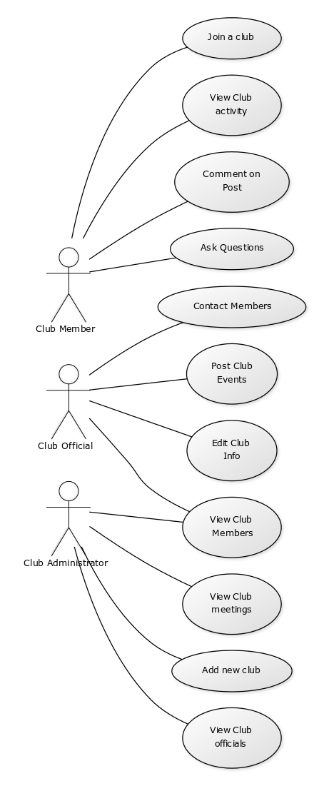

## **Data Flow Diagram**

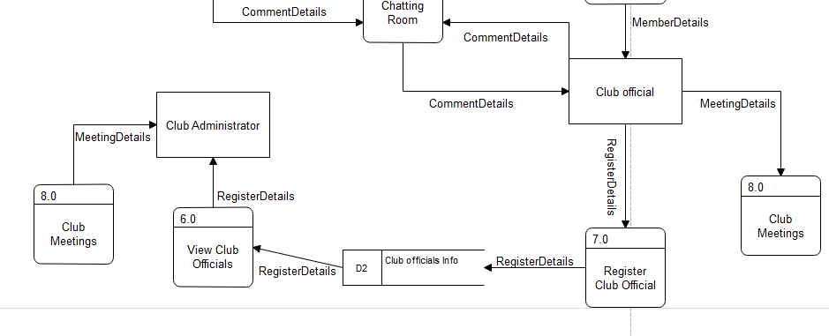

Figure 3.4: Club and Societies Web based Portal System Data-Flow Diagram

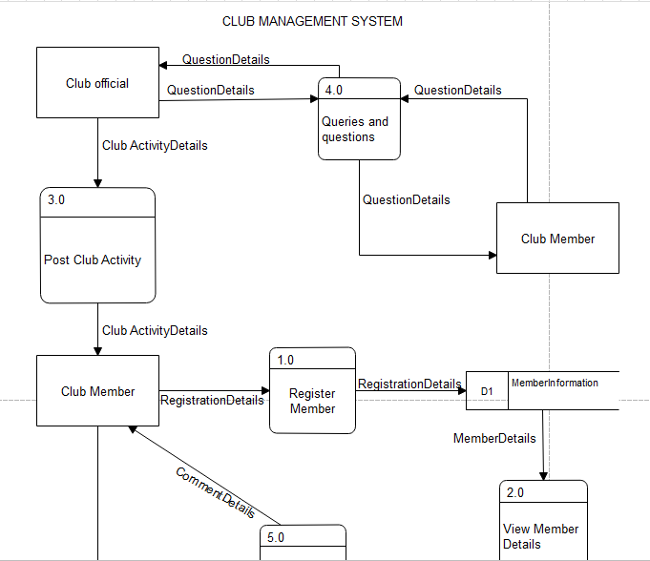

A Data-Flow Diagrams are system models that show a functional perspective where each transformation represents a single function or process (Sommerville,2016, p.134). Figure 3.4 shows how the information moves from one user to another in the Club and Societies Web based portal with some information such as member details being stored in a datastore(database).

## **Entity Relationship Diagram**

An Entity Relationship diagram shows the relationship of the entities stored in the database, an entity being a component of data (SmartDraw, 2017). Figure 3.5 shows the different entities in the database and how they are related.

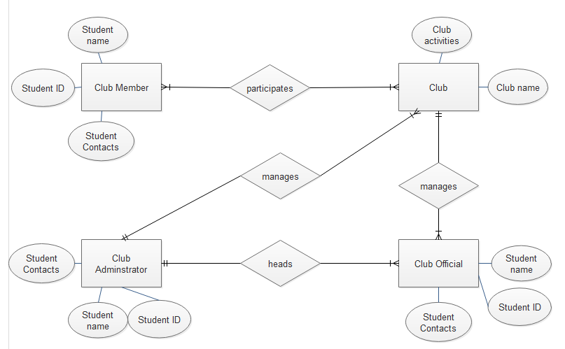

Club Management System

Table A(1): Gantt Chart TableClub Management System

Figure 3.5: Club and Societies Web Based Portal System Entity Relationship Diagram

**Chapter 5: Implementation and Testing**

## **Introduction**

## **Administrative Module**

## **Managers Landing Page**

## **Students Records**

## **System Requirements Analysis**

## **System Requirements Analysis**

## **System Requirements Analysis**

## **System Requirements Analysis**

## **System Requirements Analysis**

## **Club Official’s Module**

## **System Requirements Analysis**

## **System Requirements Analysis**

## **System Requirements Analysis**

## **Club Member’s Module**

## **System Requirements Analysis**

## **System Requirements Analysis**

## **System Requirements Analysis**

## **System Testing**

**Chapter 6: Conclusion, Recommendations and Future Works**

## **Conclusions**

## **Recommendations**

## **Future Works**

# **References**

*Clubs and Societies* . (2016). Retrieved September 9, 2017, from Discover JKUAT: http://discover.jkuat.ac.ke/category/clubs-and-societies/

Kimani, W. (n.d.). *Courses Offered At Strathmore University In Nairobi Madaraka Estate, Kenya*. Retrieved September 9, 2017, from ZaKenya: http://www.zakenya.com/education/courses-offered-at-strathmore-university-in-nairobi-madaraka-estate-kenya.html

SmartDraw. (2017). *Entity Relationship Diagram*. Retrieved September 14, 2017, from Smartdraw: https://www.smartdraw.com/entity-relationship-diagram/#whatIsERD

Sommerville, I. (2016). *Software Engineering.* Harlow: Pearson Education.

Stephens, R. (2015). *Beginning Software Engineering .* Indiapolis: Wrox, a Wiley brand .

*Strathmore Clubs Management System*. (n.d.). Retrieved September 13, 2017, from Strathmore University: https://apps.strathmore.edu/clubs/

*Strathmore University*. (n.d.). Retrieved September 9, 2017, from Top Universities: https://www.topuniversities.com/universities/strathmore-university

Strathmore University. (n.d.). *History | Strathmore University*. Retrieved September 9, 2017, from Strathmore: https://www.strathmore.edu/about-su/history/

Strathmore University. (n.d.). *Strathmore Clubs Management System*. Retrieved September 13, 2017, from Strathmore University: https://apps.strathmore.edu/clubs/

Strathmore University. (n.d.). *The Story of Strathmore*. Retrieved September 9, 2017, from Opus Dei: http://opusdei.or.ke/en-ke/article/the-story-of-strathmore-university/

*The Story of Strathmore*. (2015, September 20). Retrieved September 9, 2017, from Opus Dei: http://opusdei.or.ke/en-ke/article/the-story-of-strathmore-university/

University of Oxford. (n.d.). *Clubs and Societies*. Retrieved September 9, 2017, from University of Oxford: https://www.ox.ac.uk/students/life/clubs?wssl=1

# **Appendix**

## **Appendix A: Time Schedule**

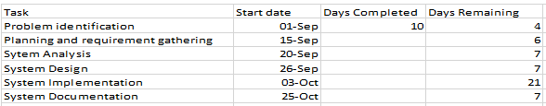

Table A(1): Gantt Chart Table

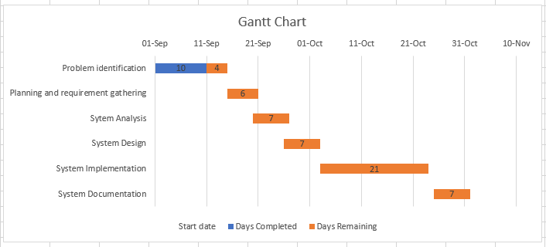

Figure A(2): Gantt Chart